Module 8 : Microservices with Spring Boot 3 and Spring Cloud

1. Creating Microservices for account and loan
In this hands on exercises, we will create two microservices for a bank.
One microservice for handing accounts and one for handling loans. Each microservice will be a specific independent Spring RESTful Webservice maven project having it's own pom.xml. The only difference is that, instead of having both account and loan as a single application, it is split into two different applications. These webservices will be a simple service without any backend connectivity.
Account.java
package com.cognizant.account.model;
public class Account {
private String number;
private String type;
private double balance;
public Account() {
}
public Account(String number, String type, double balance) {
this.number = number;
this.type = type;
this.balance = balance;
}
public String getNumber() {
return number;
}
public void setNumber(String number) {
this.number = number;
}
public String getType() {
return type;
}
public void setType(String type) {
this.type = type;
}
public double getBalance() {
return balance;
}
public void setBalance(double balance) {
this.balance = balance;
}
}
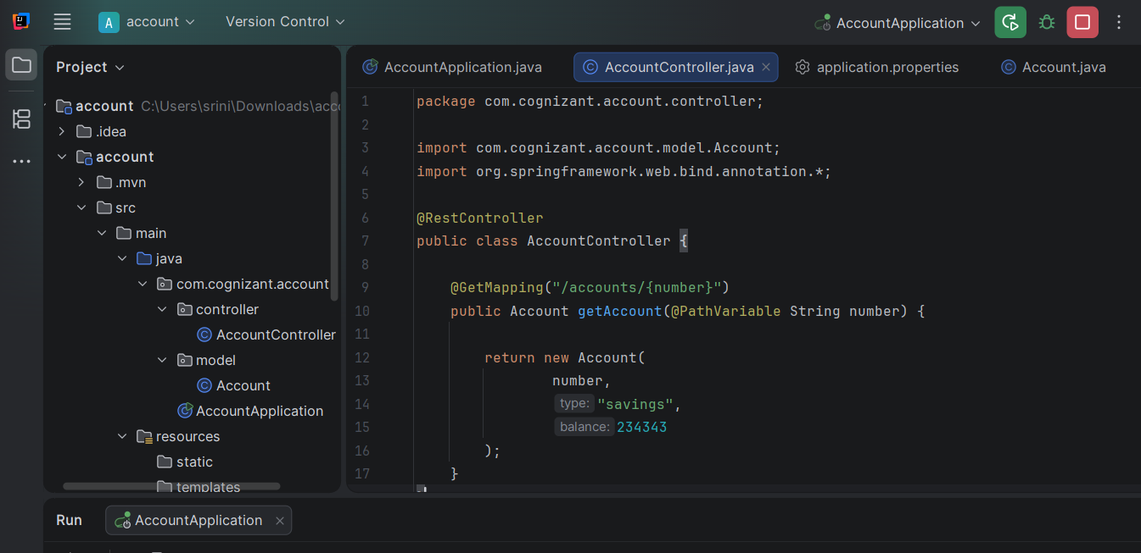
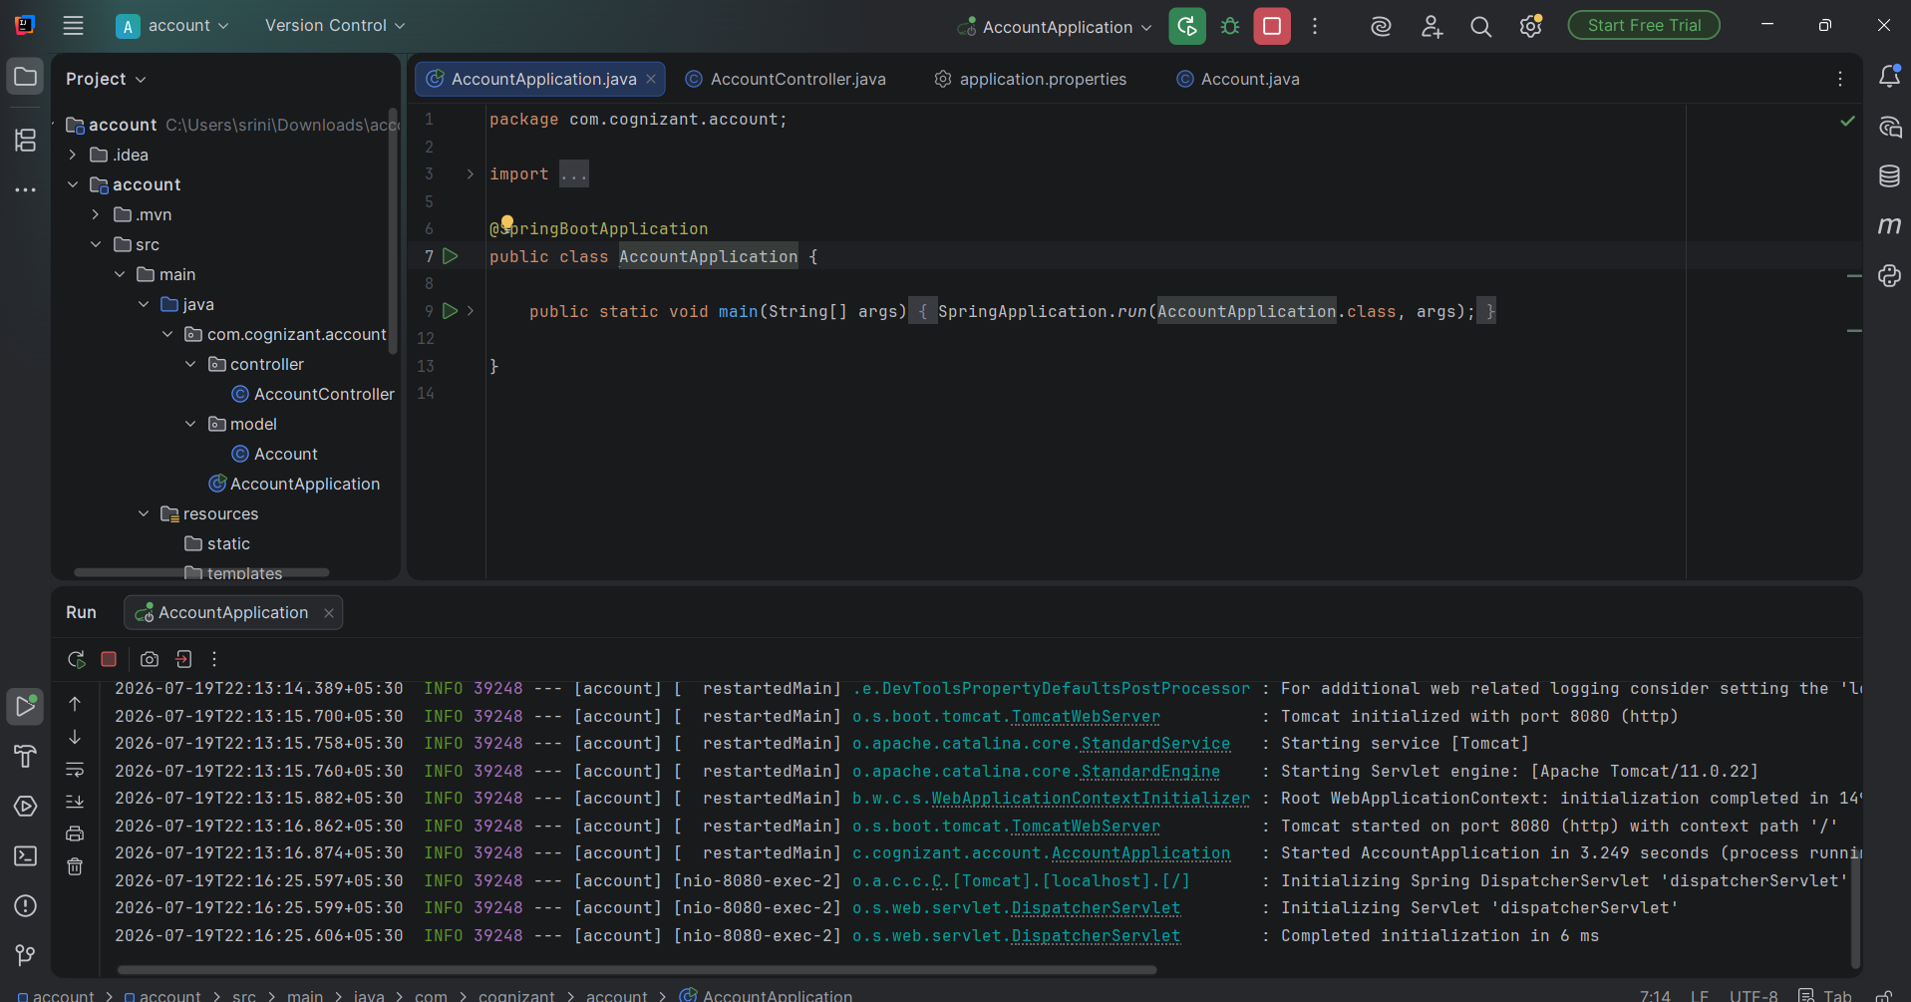
Loan.java
package com.cognizant.loan.model;
public class Loan {
private String number;
private String type;
private double loan;
private int emi;
private int tenure;
public Loan() {
}
public Loan(String number, String type,
double loan, int emi, int tenure) {
this.number = number;
this.type = type;
this.loan = loan;
this.emi = emi;
this.tenure = tenure;
}
public String getNumber() {
return number;
}
public void setNumber(String number) {
this.number = number;
}
public String getType() {
return type;
}
public void setType(String type) {
this.type = type;
}
public double getLoan() {
return loan;
}
public void setLoan(double loan) {
this.loan = loan;
}
public int getEmi() {
return emi;
}
public void setEmi(int emi) {
this.emi = emi;
}
public int getTenure() {
return tenure;
}
public void setTenure(int tenure) {
this.tenure = tenure;
}
}
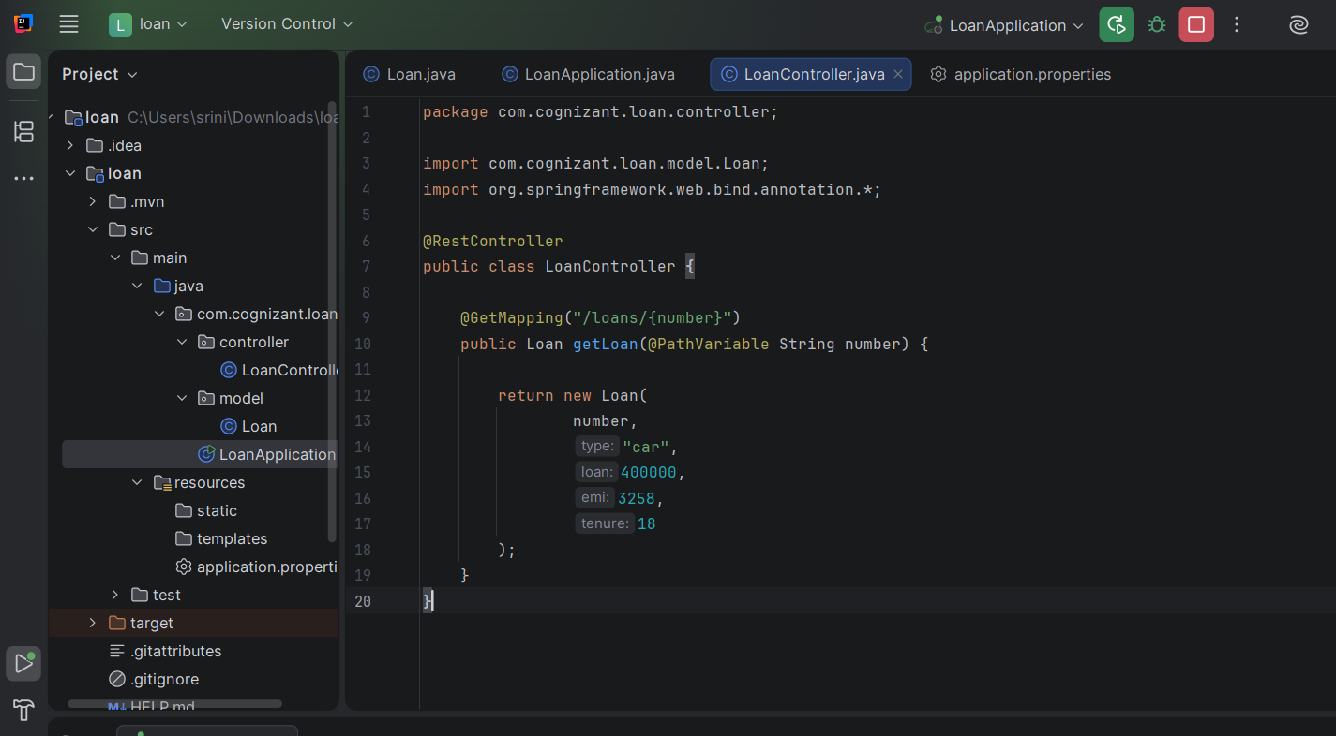
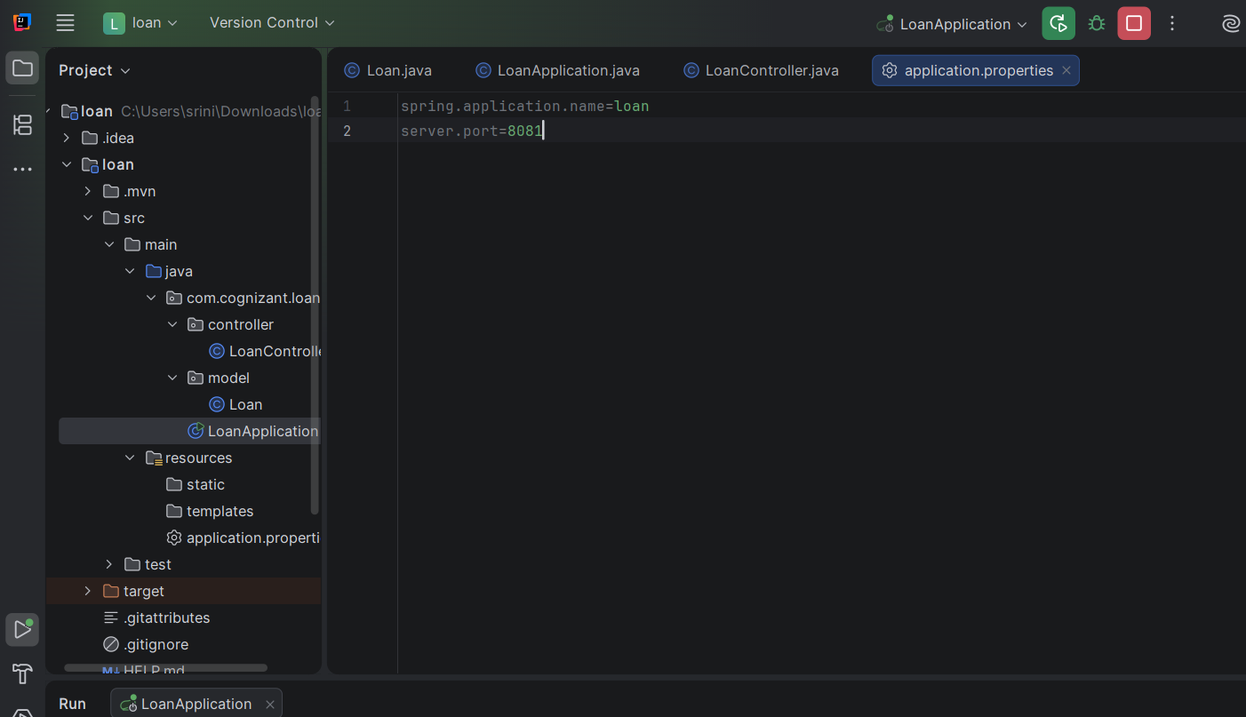
Running both the microservices:
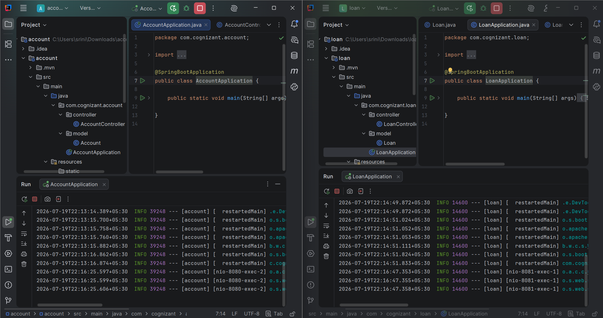
Testing APIs with postman
